**Applied Numerical Methods Problem**

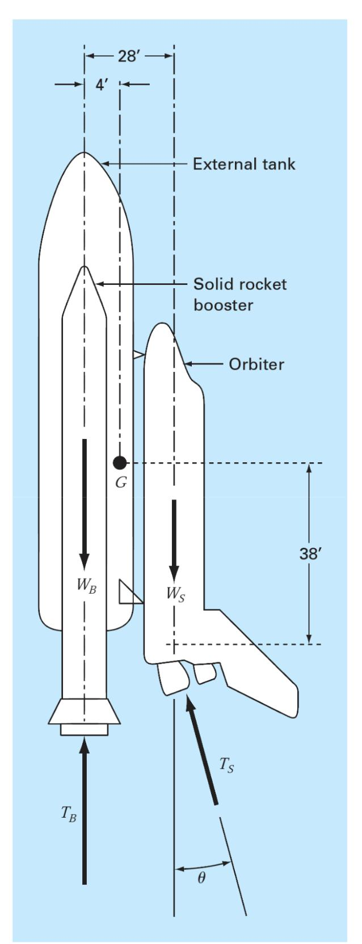**Problem:**

The space shuttle, at lift-off from the launch pad, has four forces acting on it, which are shown on the free-body diagram. The combined weight of the two solid rocket boosters and external fuel tank is WB = 1.663 × 106 lb. The weight of the orbiter with a full payload is WS = 0.23 × 106 lb. The combined thrust of the three liquid fuel orbiter engines is TS = 1.125 × 106 lb.

At lift off, the orbiter engine thrust is directed at angle to make the resultant momentum acting on the entire craft assembly (external tank, solid rocket boosters, and orbiter) equal to zero. With the resultant momentum equal to zero, the craft will not rotate about its mass center G at liftoff. With these forces, the craft will have a resultant force with components in both the vertical and horizontal direction. The vertical resultant force component is what allows the craft to lift off from the launch pad and fly vertically.

The horizontal resultant force component causes the craft to fly horizontally. The resultant moment acting on the craft will be zero when Ө is adjusted to the proper value. If this angle is not adjusted properly, and there is some resultant moment acting on the craft, the craft will tend to rotate about its mass center.

1. Resolve the orbiter thrust Ts into horizontal and vertical components, and then sum moments about point G, the craft mass center. Set the resulting moment equation equal to zero. This equation can now be solved for the

|  |  |
| --- | --- |
| value of Ө required for lift off. |  |

1. Derive an equation for the resultant moment acting on the craft in terms of the angle Ө. Plot the resultant moment as a function of the angle Ө over a range of -5 radians to +5 radians.
2. Design a rocket system with a computer program to solve for the angle Ө to find the root of the resultant moment equation. Make an initial first guess at the root of interest using the plot. Terminate your iterations when the value of Ө has better than five significant figures.
3. Repeat the program for the minimum payload weight of the orbiter of WS = 195,000 lb.

**Solution:**

1. The orbiter engine thrust has been solved into horizontal and vertical components as shown in the figure below:

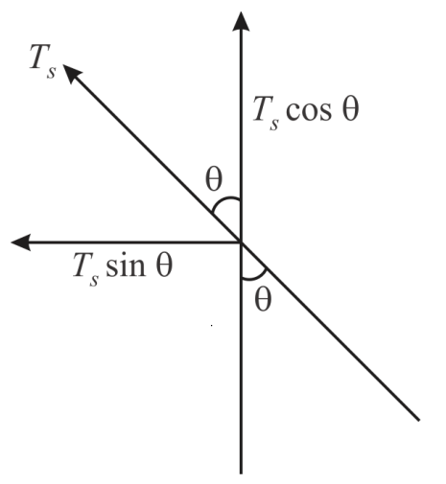

**Horizontal component:** Ts sin Ө (-ve direction)

**Vertical Component:** Ts cos Ө

**Moment about G due to Horizontal Forces, Mh** = - Ts * 38 * sin Ө

**Moment about G due to Vertical Forces, Mv** = 4 * Wb - 4 * Tb - 24 * Ws + Ts * 24 * cos Ө

So, The **Moment equation** is,

4 * Tb + 24 * Ws + Ts * 38 * sin Ө - Ts * 24 * cos Ө - 4 * Wb = 0

1. **MATLAB Code:**

clc;

clear all;

close all;

Wb = 1.663*10^6

Ws = 0.23*10^6

Ts = 1.125*10^6

Tb = 5.30*10^6

%theta = 0:0.001:1;

momentequ = @(theta) (4*Tb) + (24*Ws) + (38*Ts*sin(theta)) - (24*Ts*cos(theta)) -(4*Wb);

dmomentequ = @(theta) (38*Ts*cos(theta)) + (24*Ts*sin(theta))

theta = -5:0.00001:5;

y = feval(momentequ,theta);

plot(theta,y);

xlabel('theta');

ylabel('f(theta)');

grid on;

**Figure:**

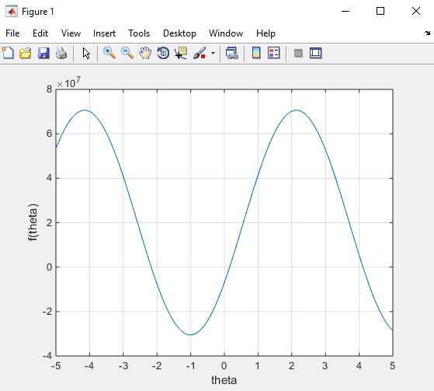

**Figure-1:** Plot of angle Ө, f(Ө).

1. **MATLAB Code:**

clc;

clear all;

close all;

Wb = 1.663*10^6

Ws = 0.23*10^6

Ts = 1.125*10^6

Tb = 5.30*10^6

%theta = 0:0.001:1;

momentequ = @(theta) (4*Tb) + (24*Ws) + (38*Ts*sin(theta)) - (24*Ts*cos(theta)) (4*Wb);

dmomentequ = @(theta) (38*Ts*cos(theta)) + (24*Ts*sin(theta))

theta = -5:0.00001:5;

y = feval(momentequ,theta);

figure(2)

plot(theta,y);

xlabel('theta');

ylabel('f(theta)');

hold on;

plot(4.113041, 0.126566, 'o');

grid on;

hold off;

r = newton(momentequ,dmomentequ,3,0.001,10)

**Newton Code:**

function r = newton(f,df,x0,es,imax)

xr = x0;

ea = 10000;

iter = 0;

fprintf('it\t\txr\t\t f(xr)\t\t error\n');

while(ea>es && iter < imax)

xrold = xr;

F = feval(f,xrold);

DF = feval(df,xrold);

xr = xrold - F/DF;

iter = iter+1;

if(xr ~=0)

ea = abs((xr-xrold)/xr)*100;

end

fprintf('%d \t %f \t %f \t %f \n' , iter, xr, F, ea);

end

r = xr;

end

**Figure:**

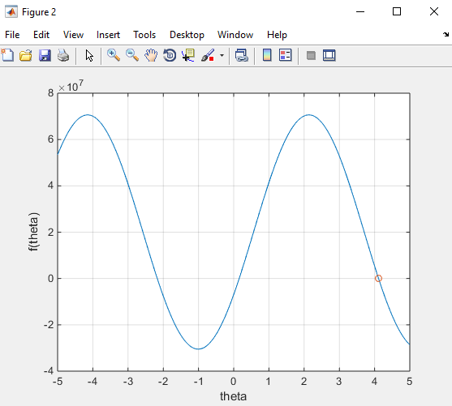

**Figure-2:** Plot of angle Ө, f(Ө) with root.

**Command Window:**

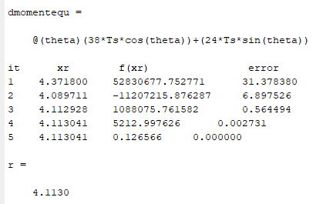

1. **MATLAB Code:**

clc;

clear all;

close all;

Wb = 1.663*10^6

Ws = 195000

Ts = 1.125*10^6

Tb = 5.30*10^6

%theta = 0:0.001:1;

momentequ = @(theta) (4*Tb) + (24*Ws) + (38*Ts*sin(theta)) - (24*Ts*cos(theta)) (4*Wb);

dmomentequ = @(theta) (38*Ts*cos(theta)) + (24*Ts*sin(theta))

theta = -5:0.00001:5;

y = feval(momentequ,theta);

plot(theta,y);

xlabel('theta');

ylabel('f(theta)');

hold on;

plot(4.095010, 0.080550, 'o');

grid on;

hold off;

r = newton(momentequ,dmomentequ,3,0.001,10)

**Newton Code:**

function r = newton(f,df,x0,es,imax)

xr = x0;

ea = 10000;

iter = 0;

fprintf('it\t\txr\t\t f(xr)\t\t error\n');

while(ea>es && iter < imax)

xrold = xr;

F = feval(f,xrold);

DF = feval(df,xrold);

xr = xrold - F/DF;

iter = iter+1;

if(xr ~=0)

ea = abs((xr-xrold)/xr)*100;

end

fprintf('%d \t %f \t %f \t %f \n' , iter, xr, F, ea);

end

r = xr;

end

**Command Window:**

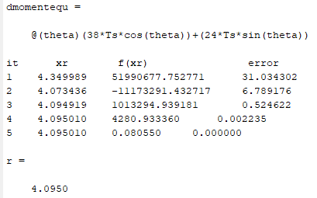

**Figure:**

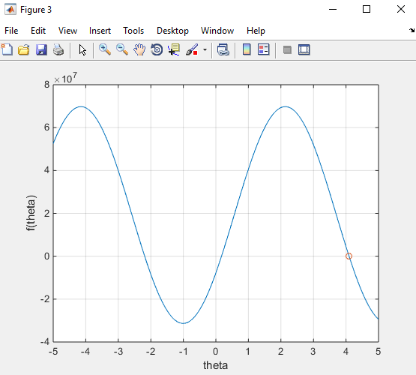

**Figure-3:** Plot of angle Ө, f(Ө) with root.

**Conclusion:** I have solved the root in this problem using Newton-Raphson method. Since the Newton-Raphson method (also known as Newton's method) is a way to quickly find a strong root approximation of a real-valued function f(x)= 0. It uses the idea that it should be approximated by a straight line tangent to a continuous and differentiable function. So, I make the initial first guess for the first MATLAB code is 3. After 5 significant figure the root was 4.1130 and the error was 0. Again, in second MATLAB code, I make the initial first guess is 3. The root was 4.0950 and the error was 0. Like this problem, we can solve real-time problem by Newton-Raphson method.